# Homework 1

Problem 1

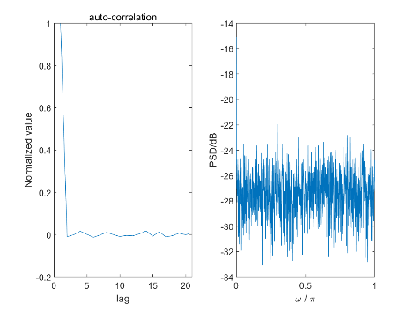

Figure 1. Autocorrelation and PSD for input signal

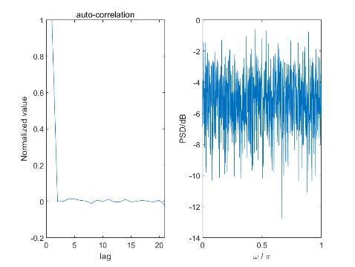

Figure 2. Autocorrelation and PSD for White Gaussian Noise

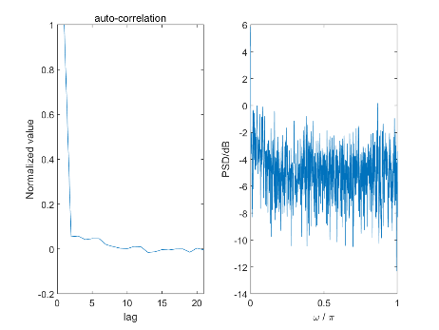

Figure 3. Autocorrelation and PSD for output

From Figure (1)-(3), except some points, auto-correlation is almost 0, and is equal to 1 when zero lag, so signal is uncorrelated. Furthermore, PSD is up and down around a constant. Then we can assume it is a noise.

i.&ii.

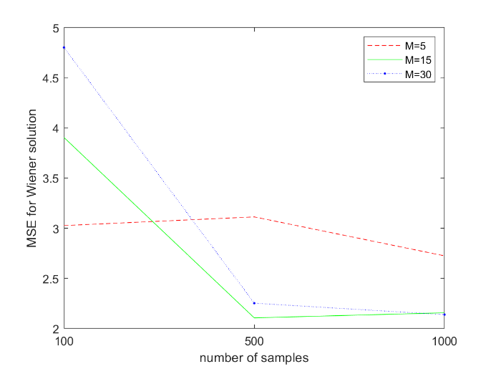

Figure 4. MSE for wiener solution at different number pf samples and different modes

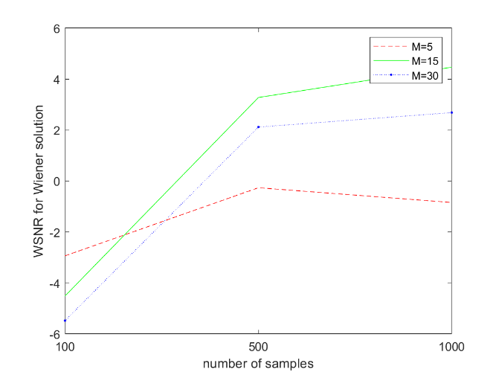

Figure 5. WSNR for wiener solution at different number pf samples and different modes

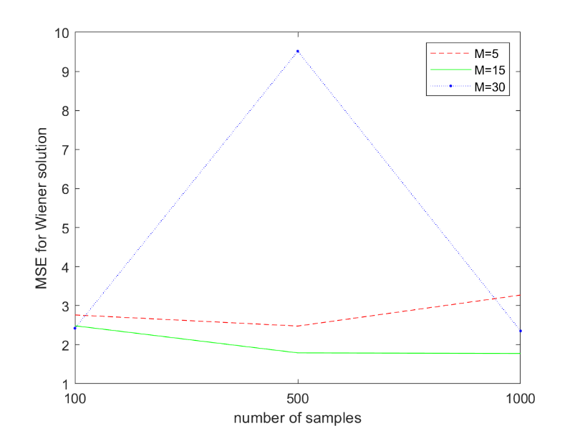

Figure 6. MSE for LMS

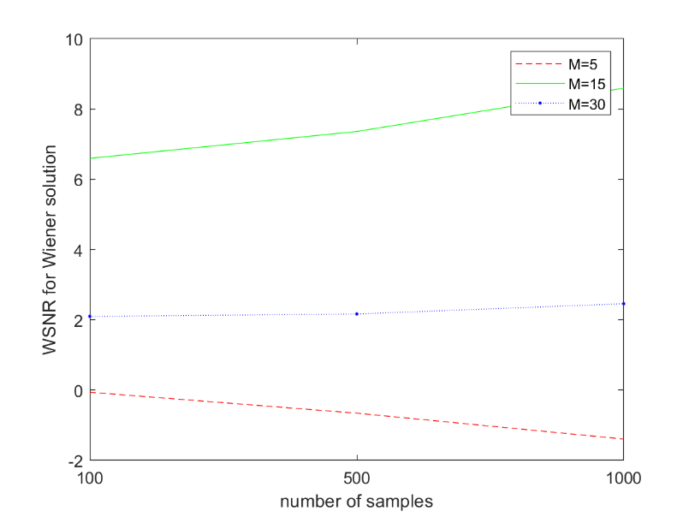

Figure 7. WSNR FOR LMS

According to Figure (4) – (7), for both wiener solution and LMS algorithm, M = 15 has the lowest MSE and highest WSNR, which means the accuracy is highest. In theoretically, higher mode provides higher accuracy, but here we do not have enough data to support so complex mode which leads to a lower accuracy.

For window size, we can find if our data is not enough, for example only 100, we may get a relatively bad result. We can find when number of samples increasing, all curves indicates higher accuracy. So we should take samples as much as we can, the more data, the higher accuracy.

iii.

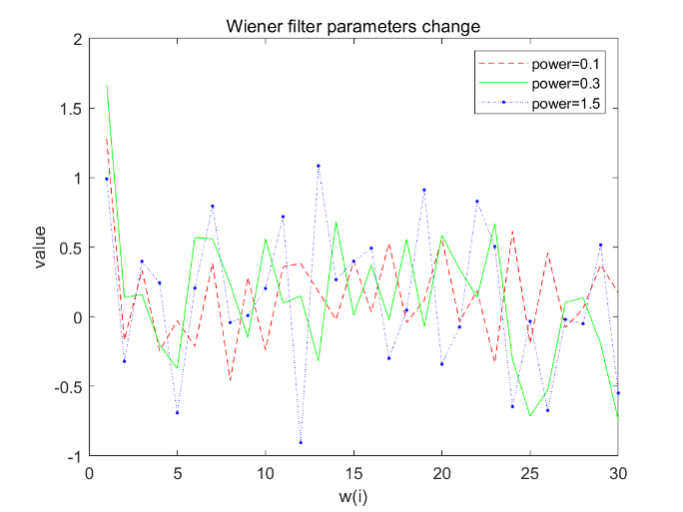

Figure 8. wiener parameters change when M=30, N=1000. Each point indicates w(i) and its corresponding value

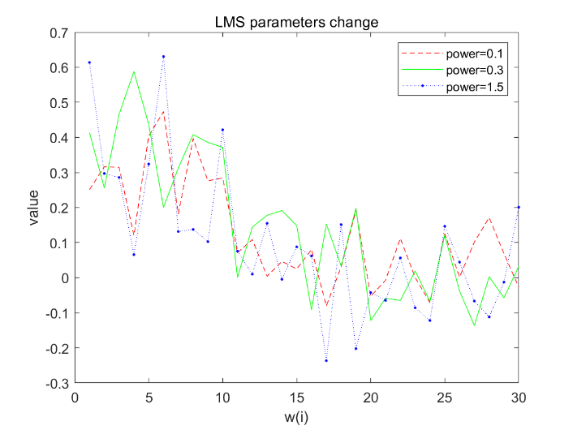

Figure 9. LMS parameter change when M=30, N=1000. Each point indicates w(i) and its corresponding value

In fact, I cannot find obvious change in both wiener filter and LMS parameters. The change of Gaussian noise does not affect w very much. Gaussian noise will be attenuated through learning. But higher power of Gaussian noise does cause a higher MSE.

By comparing MSE and WSNR from Wiener solution and LMS, LMS has a higher WSNR. But in fact, they are almost same. Maybe LMS is better processing signal added with noise. If no noise is added, wiener filter can achieve almost zero error processing.

Problem 2

i.

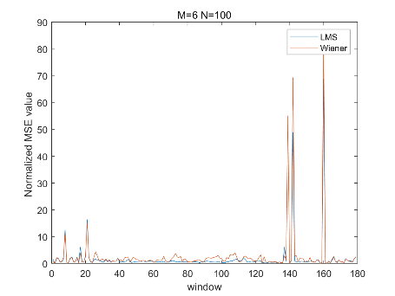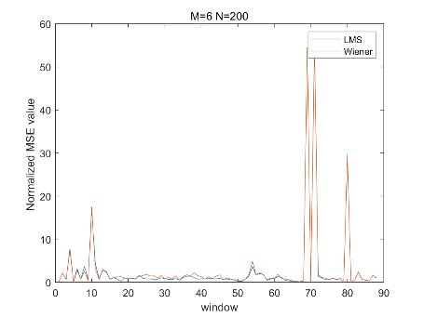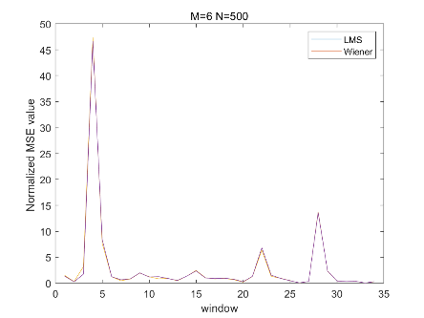

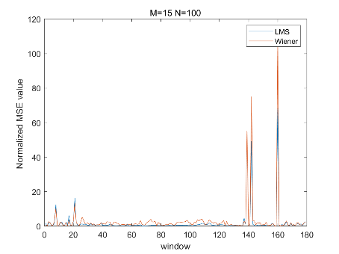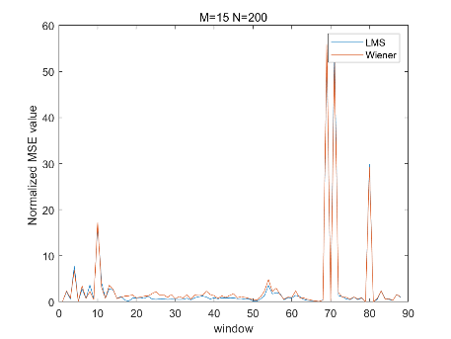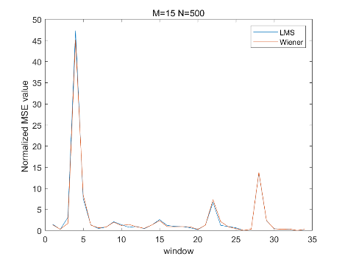

Figure 10. MSE for different values of M (filter order) and N (window size) for wiener solution and LMS. X axis window means ith window of entire signal, window size is equal to N.

Change of filter order does not change the result too much. We can find a obvious reduction of MSE when increasing window samples.

ii.

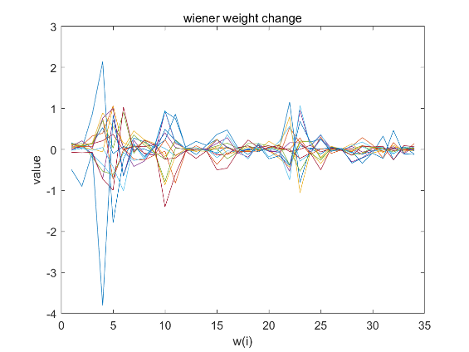

Figure 11. Wiener weights change. Window size N=500. Each curve indicates the change of a specific w(i) in jth window. We can find the change of w(i) in the time line.

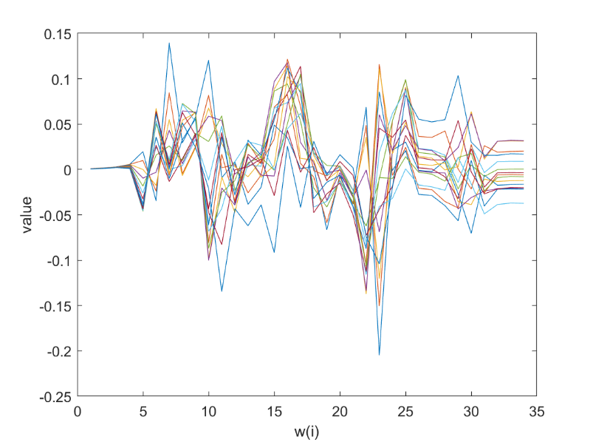

Figure 1. LMS parameters change. Window size N=500. Each curve indicates the change of a specific w(i) in jth window. We can find the change of w(i) in the time line.

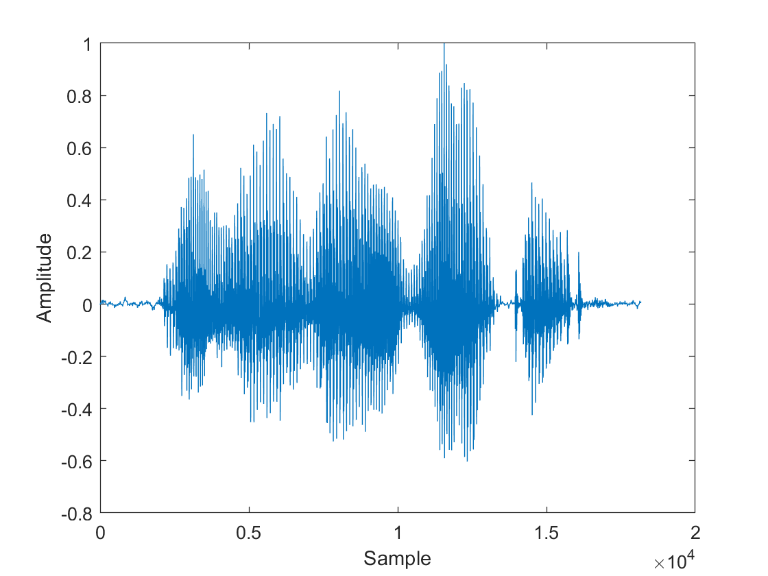

Figure 13. Amplitude of speech signal

Compared to the original speech signal. In wiener parameters, W is larger and changes faster when the change of speech is faster. But for LMS, parameters are affected not only by present input but also by past input, so parameters change smaller.

iii.

In my MSE figure, there are several window points which have extraordinary error spikes. When comparing them on time axis, we can find exact match. When frequency changing dramatically, from blue part to yellow part in spectrogram, MSE error spikes appear. Maybe we can change wiener parameters faster or using a relatively large learning rate when there is a dramatic change in frequency. We can find at some points, frequency changes very fast, if we choose a bad learning rate, we are easy to diverge, so convergence is important.

iv.

In terms of MSE, Wiener solution and LMS have almost same performance. LMS ’s MSE is a little smaller at some points. And parameters of LMS is much stable.